Follow Canada Walks on Twitter (@CanadaWalks) or Facebook for Winter Walk Day news and updates. Event hashtags: #winterwalkday #walktoschool #winterwalkphoto
Sample messages for websites/newsletters/assemblies:
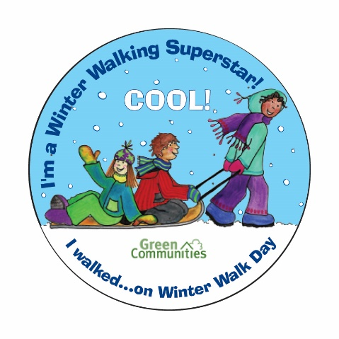
Winter Walk Day 2018 – General Announcement
February 7th 2018 is #WinterWalkDay across Canada. It’s the perfect opportunity for parents and kids to get outside together and stretch those legs! Walk to school or at school for daily physical activity, a healthier environment, safer streets, making friends and ... having fun! Walking is the simplest form of exercise and helps kids get those 60 minutes of daily physical activity they need. It’s also a great cure for those winter blues and helps students concentrate better in class.
For tips on how to dress for winter walking and ideas for celebration events, visit Active and Safe Routes to School where you’ll find a Winter Walk Day kit available for download, including posters, sample announcements and sticker templates! Don’t forget to share your experiences with the hashtag #WinterWalkDay and #WalktoSchool
Schools that celebrate Winter Walk Day in February can register their event online and receive a certificate of participation from Canada Walks:
http://www.saferoutestoschool.ca/winter-walk-day _________________________________________________________________
Wednesday February 7th is Winter Walk Day!
Keep active this winter and join schools across Canada to celebrate Winter Walk Day. Dressing warmly for a brisk winter walk can be exhilarating and fun – give it a try on February 7, here are some ideas:
- If you can walk safely to school, wrap up warm, leave the car at home and travel to school on foot with your friends.
- If you live too far to walk the whole way, try getting dropped off at a friend’s house or a few blocks away from the school so you can walk the last leg
- If you take the school bus, have a winter walk in the school yard at break time so you can get active too!
___________________________________________________________________________
Winter Walking Tips:
- Keep hands and head covered to prevent heat loss.
- On really cold days wear a scarf over your face and mouth.
- Wear warm, waterproof boots.
- Wear a warm coat that deflects the wind.
- Woolen clothing helps to retain the heat.
- Wear clothing or carry knapsacks with reflective material – it’s important to be seen.
- If possible, change wet clothes at school – tuck an extra pair of socks and mitts into knapsacks.
Click here for more information on Active & Safe Routes to School.
___________________________________________________________________________

Winter Walk Day
Keep active this winter! We are celebrating Winter Walk Day on Wednesday February 7th, 2018. Grab your mittens, hats and boots and be a part of this fun winter event!
___________________________________________________________________________

Sample Newsletter Templates
Sample Newsletter Template- Week Before Winter Walk Day
We are excited to announce that <<Name of School>> will be taking part in Winter Walk Day next Wednesday February 7!

Walking to school in winter has many potential benefits, including benefits for your child’s health and well-being (like opportunities to learn and socialize on the way to school, and arriving to school alert and ready to learn), our community (reduced traffic congestion around the school) and the environment, too.

<<Describe the event- will there be music, hot chocolate, stickers? Coffee inside for the parents and a chance to meet other parents?>>

Walk with your child to school next Wednesday to join in the celebration! If you’re on your way somewhere else and plan on driving to your next destination, consider walking and taking transit (see Google maps for available transit routes to/from your destination: https://www.google.ca/maps), or park/drop your child off a block or two away from the school to walk the rest of the way in. If you’re not able to join, encourage your child to walk with a friend.

To check out some Winter Walking Tips, see <<link to resource(s)>>.

To be part of the conversation on Twitter: Use the hashtag #walktoschool; and if you don’t already, follow @CanadaWalks and @(School Twitter Account)!

___________________________________________________________________________
Newsletter Template- Week of Winter Walk Day
Come join us this Wednesday February 7 as our school takes part in Winter Walk day, a celebration of the unique joys of walking to school in the chilly, snowy days of winter.

<<Describe the event- will there be music, hot chocolate, stickers? Coffee inside for the parents and a chance to meet other parents?>>

Walk with your child to school this Wednesday to be part of the fun. If you’re on your way somewhere else and plan on driving to your next destination, consider walking and taking transit (see Google maps for available transit routes to/from your destination: https://www.google.ca/maps), or park/drop your child off a block or two away from the school to walk the rest of the way in. If you’re not able to join, encourage your child to walk with a friend.

To check out some Winter Walking Tips, see <<link to resource(s)>>.

To be part of the conversation on Twitter: Use the hashtag #walktoschool; and if you don’t already, follow @CanadaWalks and @(School Twitter Account)!
___________________________________________________________________________

Newsletter Template- Week after Winter Walk Day
Thanks to everyone who joined us last week for Winter Walk Day at <<Name of School>>. Our school took part in a celebration of walking to school in winter, to show that walking to school is not just for warm sunny days. As the old saying goes: there is no bad weather- just bad clothing choices!
{Include pictures from Winter Walk Day event}
Thank you to all the students, staff, volunteers and parents at our school who helped us increase awareness and enthusiasm for walking to school in winter. Let’s keep it up! Bundle up and get some fresh air and sunshine as you take part in a healthy active lifestyle with your child, every day.

To be part of the conversation on Twitter: Use the hashtag #walktoschool; and if you don’t already, follow @CanadaWalks and @(School Twitter Account)!

___________________________________________________________________________

