Template Instructions
Remove this Instructions page from final document.
The School Travel Plan
This template is designed to help facilitators collect information throughout the School Travel Planning process to make School Travel Plan preparation easier by providing all the components in one place. The footer automatically changes page numbers so you can add text and photos and/or delete the pages you do not use so that your finished document flows smoothly. The Table of Contents page has further instruction.
Yellow highlighting signifies text holders to be filled in or note sections to be deleted. No highlighting should remain in the final product.
Essential pages:
- School Profile
- Goals
- Travel Challenges Summary
- Baseline Data Collection – summary of findings (surveys and walkabouts)
- Team and Endorsement
- Evaluation – summary of follow-up findings
- Annual Update
- ACTION PLAN (and it’s updates)
In addition to the essential pages, the School Travel Plan document could also include:
- A Timeline of Main Tasks
- A Traffic Count section
- Support Documents
- Students’ artwork examples
- Artwork and photos to illustrate projects and successful actions
- Engineering drawings for infrastructure changes
After a school agreement has been signed, the School Profile can be completed with the school principal and office staff. This will start your School Travel Plan.
Some items on the Timeline of Main Tasks will be filled in with the school principal (for instance dates surveys are carried out in class and with parents), and other items will be filled in with the School STP Committee and the Municipal Stakeholder Committee. The Baseline Data Collection - summary of findings will involve companion materials (surveys, walkabout instruction, traffic observation and count tools) used to collect data. Examples of summary reports are in the STP Toolkit under ‘Community Samples.’
The Action Plan contained in this template is used early on in the process; you should take it to the meeting you hold on the day of the Walkabout so that identified action items and those responsible for carrying them out can be written in immediately. Once essential pages and any additional sections are completed, the School Travel Plan should be signed by the Municipal Stakeholder Committee and School STP Committee leads.
PLAN UPDATE
The School Travel Plan is a living document to be updated regularly after evaluation and as new information arises. The Action Plan should be regularly updated; the Annual Update page can record official signatories.

<School Name>
School Travel Plan

<date>

<school photo>

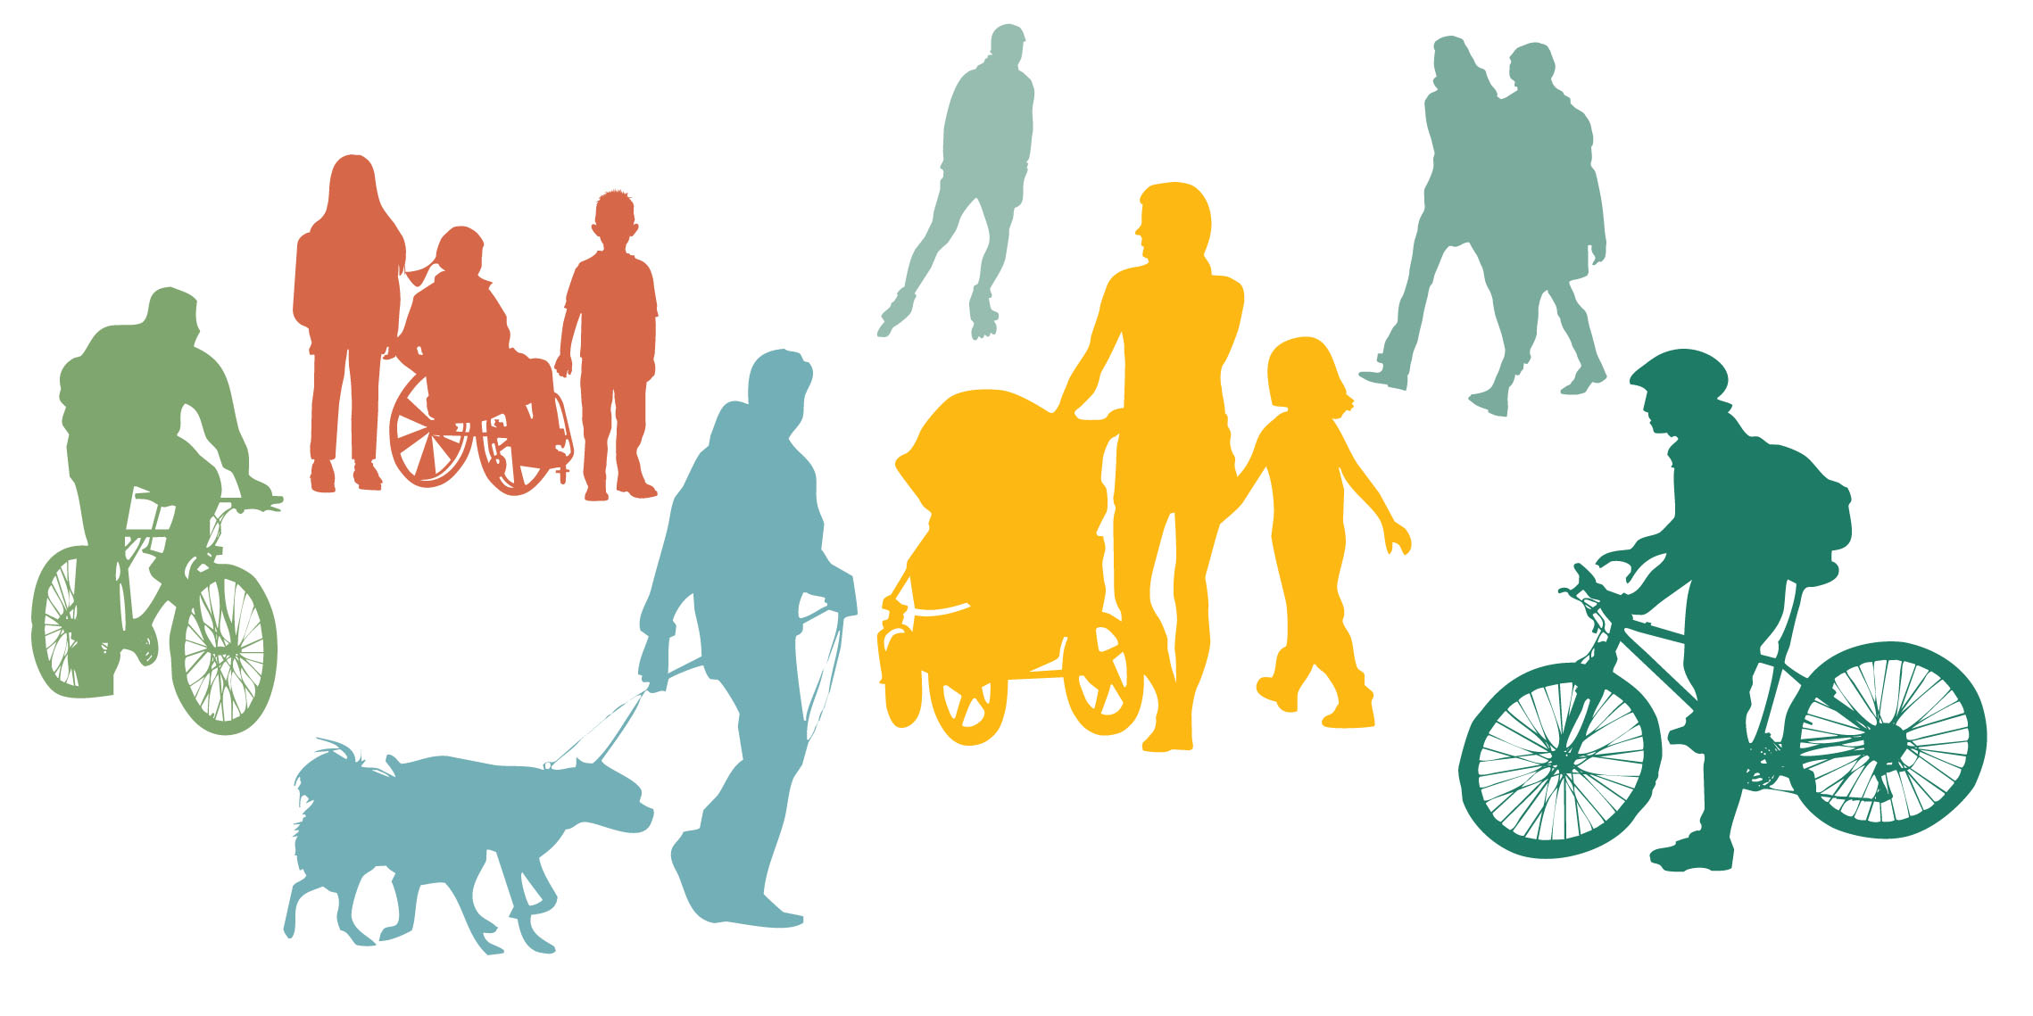




<Insert other logos here>

Table of contents

[Note: The table of contents automatically detects the locations of text under the Heading 1 and Heading 2 styles. To add other sections illustrated in the Table of Contents, click on page preceding where you would like to insert your text, go to Page Layout in the upper tool bar, click Breaks then Next Page. The header automatically has the words School Travel Plan and an image on the left. At the top of the new page, make sure that your title that you would like to include in the Table of Contents is under the Heading 1 Style. Subheadings can go under the Heading 2 Style. Once you are finished, highlight the Table of Contents, and update.
Remove these instructions in the final document.]

Table of contents 1
Introduction 2
About School Travel Planning 2
About STP in <local jurisdiction> 3
About the School 4
School Profile 4
Map of area covered by this School Travel Plan 5
Timeline of Main Tasks 6
Goals 7
Travel Challenges Summary 8
Baseline Data Collection – summary of findings 9
Student Classroom Survey Findings 9
Walkabout 10
Student Walkabout 11
Family Survey Findings 12
Traffic Count Findings 13
Evaluation - summary of follow-up findings 15
Implementation 16
Completed Action Plan Items 16
Team and Endorsement 17
Annual Update 19
Support Documents 19
Appendix: ACTION PLAN 20

Introduction

About School Travel Planning

A School Travel Plan is a living document belonging to the school. It will be revisited regularly in order to update the status of Action Plan items and to incorporate future Evaluation findings. It is part of a complete School Travel Planning process that has been successfully developed and implemented across Canada since 2007.
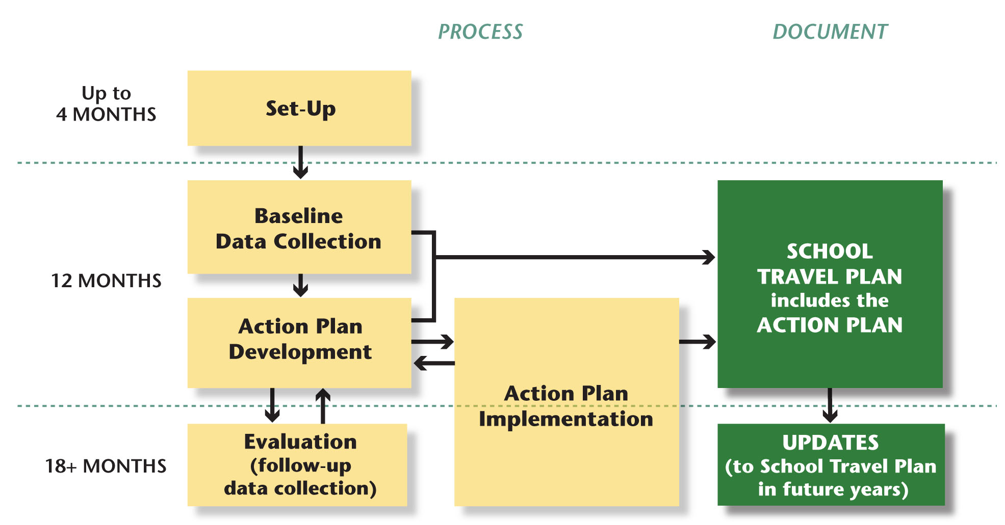

The national Children’s Health, Mobility and Happiness: A Canadian School Travel Planning Model project completed in 2012 used Active and Safe Routes to School programming combined with Transportation Demand Management principles to encourage active and sustainable modes of school travel for students, families and staff. The project was designed to address barriers to active travel caused by attitudes and car-dominated design in school neighbourhoods in an effort to reduce the health risk to children. Even before many Action Plan items had been fully implemented, by March 2012 some provinces saw a shift towards active travel of up to 6 per cent and some individual schools saw a shift of over 20 per cent.
Results from STP work between 2014-16 demonstrate that the STP program is a cost-effective intervention.
When effectively coordinated and implemented STP can result in
positive school travel behaviour change, and ultimately provide substantial economic, environmental and physical activity benefits.

Green Communities work in Ontario shows that the STP model performs well in a variety of community settings – inner city, inner and outer suburbs, and rural. When travel mode data was combined with the actual costs of delivering STP the results were very encouraging: a benefit cost ratio of 2.4 after one year of implementation.

National resources
School Travel Planning (STP) is presented by a coalition of organizations across Canada working together to enable more children to walk and cycle to school. Green Communities’ Canada Walks makes coordination of efforts and knowledge transfer between and among these organizations possible. This national website provides a wealth of resources with links to international and provincial/territorial organizations and their curriculum, as well as to campaigns that can benefit and complement a school’s efforts for health promotion and environmental awareness:
www.saferoutestoschool.ca

Toolkit resources and flexible templates are available to use in every phase of the STP process. Find the toolkit at:

www.saferoutestoschool.ca/school-travel-planning

About STP in <local jurisdiction>

Description

About the School
<date>

School Profile
School Name

School Type, e.g. public, separate, private

Age of School / Year Opened

Name of School Board

Number of Students

Number of Families

Grades, e.g. K-6, K-8

School Bell Times

Number of Parking Spaces, staff/visitor

Description of Location, e.g. city centre/suburban/rural
Is the school in a Neighbourhood Watch or Block Parent Community?
% Bussed Students

Socio-Economic Description of Families

Any local programs e.g. French immersion, fine arts, special needs, before and after-school day care etc.

Existing Facilities At School Site, e.g. bike rack/storage, kiss ‘n ride, school bus drop-off zone, adult or student crossing guards, public transit bus stops serving school, transport arrangements to after school programs

Existing Safety Policy & Education, e.g. school safety policy and rules, current safety education programs

Programs at this school that have goals similar to STP, e.g. environmental, physical activity, mental health

Types of school/parent committee communications used/available (i.e. newsletter, website, facebook page)

Other Information

Map of area covered by this School Travel Plan

<Insert school area map here>

Timeline of Main Tasks

[Note: This table can also include committee meeting dates and event dates, as you choose.]

Task | Start Date | End Date | Actual End Date
PROJECT PREPARATION AND DATA COLLECTION
Complete School Profile
Inform school and parents about project
Conduct Baseline Classroom Surveys over five consecutive days
Conduct Baseline Family Survey
Enter and analyze data from Baseline Classroom Surveys
Enter and analyze data from Baseline Family Surveys
Analyze returned family route maps
Conduct Traffic/Pedestrian/Cyclist Observation and Count
Conduct School Walkabout
Analyze baseline data and compile summary report with graphs
Communicate baseline results to school community
ACTION PLANNING
Finalize Action Plan with approval by stakeholders assigned tasks
Obtain signatures in School Travel Plan from School and Municipal Committee Leads
Communicate School Travel Plan to school community
IMPLEMENTATION
Inform school community about impact of Action Plan implementation
Celebrate! (Theme Day chosen)
ONGOING MONITORING
Conduct Follow-up Classroom Surveys after one year
Conduct Follow-up Family Surveys
Enter and analyze data from Follow-up Classroom Surveys
Enter and analyze data from Follow-up Family Surveys
Prepare summary report of follow-up data
Update Action Plan
Endorse School Travel Plan update

Goals

School Travel Planning goals

Throughout the STP process, stakeholders have identified the following goals for <school name>:
- Reduce congestion and increase safety at the school site
- Increase active school travel on the school journey

Key goals for this school

Based on the Baseline Classroom and Family Survey findings, this school’s key goals in order to assist the health and well-being of our students and families are:

[Note: these are example points for your edit
- Educate, with the help of…
- Hold Walk to School Days
- Set up walking groups on defined best routes to school
- Increase the number and security of bike racks
- Work towards infrastructure improvements]

Specific action items are detailed in the Action Plan (see Appendix).

Travel Challenges Summary

This section presents the main travel challenges at <school name> identified by the Walkabout with stakeholders, family surveys with route mapping, and school community meeting consultations collected before <date>. Please see the Action Plan in Appendix A for upcoming or existing actions intended to facilitate improvements.

<1. Issue + Description + photo (optional)
2.
3.
4.
5.
6.
7.
8.
9.
10.>

Baseline Data Collection – summary of findings

Student Classroom Survey findings

All classrooms: Student Survey Total Travel Mode to School Over One Week

<Insert graph>

All classrooms: Student Survey Total Travel Mode from School Over One Week

<Insert graph>

Walkabout

The <school name> walkabout took place on <date(s)>, with representatives from: <list of stakeholder representation - does not need individual names>. Walkabouts inform the Travel Challenges section <pages x to x>, Action Plan <Appendix A page x> and mapping of active travel best routes and park and walk options for long distance families.

<Insert photo from Walkabout>

Weather:

Main findings (optional)
< any information not covered in the Travel Challenges section>

An example of a Walkabout Summary is in the STP Toolkit at www.saferoutestoschool.ca/school-travel-planning under ‘Community Samples.’

Student Walkabout

With permission and assistance from the Principal, the student walkabout took place on <date(s)>, with representatives from: <list of student representatives who have permission based on grade or age, maybe gender. Mention if any students do not have permission to be named here.>

<Insert photo from Walkabout>

Weather:

Lessons Learned
<information on key concerns/needs, what works, what does not work>

Main findings (optional)
<information not covered in the Travel Challenges section>

Family Survey Findings

<Insert graphs. Use those that illustrate the most important findings from your school.>

Traffic Count Findings

[Note: Traffic counts of pedestrians, cyclists and vehicles range from one day observation and counts before and after school, to full week counts. Example Traffic Counts are in the STP Toolkit under ‘Community Samples’.]

Evaluation - summary of follow-up survey findings

Student Classroom Travel Survey follow-up findings

All classrooms: Student Follow-up Survey Total Travel Mode to School Over One Week

<Insert follow-up graph>

All classrooms: Student Follow-up Survey Total Travel Mode from School Over One Week

<Insert follow-up graph>

Family Survey Follow-up Findings

<Insert follow-up graphs. Use those that illustrate the most important findings from your school.>

Implementation

Completed Action Plan Items

<Name>

<description and photos>

<Name>

<description and photos>

<Name>

<description and photos>

Further updates on other action plan items can be found in the Appendix.

Team and Endorsement

Committee members

Members of the School STP Committee
Principal <name>
Teacher Representative <name>
Parents <names>
Students <names>

Members of the Municipal Stakeholder Committee, and advisory persons
STP Facilitator <name>
[Note: These are suggested committee member titles, please insert you own titles and the person’s name]
Planning Department Representative <name>
Engineering Department Representative <name>
School District Representative <name>
Public Health Representative <name>]
Elected Mayor or Councillor <name>
Elected School Board Representative <name>
Community Organizations/Advisory persons <name>
Etc.

Endorsement

The School Travel Plan for <school name> has been endorsed by Principal <name> on behalf of the school, and by key representatives of the Municipal Stakeholder Committee.

School Principal: ___________________________________

Signature: ___________________________________

Date: ___________________________________

Lead representative of the
Municipal Stakeholder Committee: ___________________________________

Signature: ___________________________________

Date: ___________________________________

Annual Update

Principal Municipal Lead

End of Second Year <Insert date> ___________________________ __________________________

End of Third Year <Insert date> ___________________________ __________________________

End of Fourth Year <Insert date> ___________________________ __________________________

End of Fifth Year <Insert date> ___________________________ __________________________

[Note: More dates can be added]

Support Documents

<relevant documents>

How an Action Plan works
This Action Plan should include short, medium and long-term measures. Every row should be completed with the most accurate information possible. Short-term measures must identify who will be responsible for the tasks and target completion dates. Long-term measures should list a specific person but could alternately assign a department or organization. Where possible, collect current cost estimates so that everyone is working with realistic budget figures.
[Note: The following Action Plan table contains suggested examples. Edit to suit your school]

Action Plan for <school name>
Action/Initiative | Tasks | Responsibility | Start Date | Completion date | Estimated Cost and Source of Funds, or No Cost
Objective 1: To improve the safety of children on the active school journey
Road safety lessons | Seek road safety curriculum resources for classroom teaching | <name> | <Month/year> | <Month/year> | <$ and source>
Parent role modeling messaging | Provide messages for use in school and parent communications
Road safety/personal safety presentation | Contact community police to present to an assembly
Improve vehicle and walker/cyclist separation at and on school site | A site study by school district staff/municipal advisors
Construct missing sidewalk on school frontage street | Seek approval for funding. Construct sidewalk.
Improve visibility of crosswalk at… | Order hedge trimming and warning signage
Personal safety education | Presentation about Block Parent program to all JK to grade 5 classes
School Zone Signage enhancement | Install new School Safety Zone signs around school
Traffic calming | Curb bump-outs at _______ intersection
Best Walking Routes Map Pamphlet | Create map showing best routes and distribute to families along with walking safety information
Objective 2: To raise the awareness of the environmental and health benefits of active travel
Implement an idle-free zone campaign | Contact a suitable organization to assist
Have students create artwork for temporary outdoor signage | Identify class that can make this an art project or run a contest
Have physical activity benefits messaging in newsletters | Review information on Public Health Agency of Canada website
Sustainable Happiness lesson plans | Distribute teacher resources found at www.sustainablehappiness.ca
Hold a walk to school week during Canadian Environment Week | Organize
Objective 3: To encourage more students to walk to school
Drop & Go / Walk a Block or Two | Identify suitable locations for students to be dropped off outside the school zone
Buddy Scheme | Set up scheme to encourage students to walk and cycle with others
Neighbourhood Walking School Bus | Identify a route from a suitable neighbourhood to school. Organize WSB.
IWALK (International Walk to School Month – October) | Organize a Walk to School Week
Walk to School Days | Detail a challenge and advertise Walking Wednesdays
Appropriate dress | Organize a fashion show for Be Seen, Be Warm …
Celebration | Organize a community walk to school with local dignitaries on Earth Day
Hold Commuter Challenge | Organize
Objective 4: To encourage more students to walk from school to after-school programs
Walking School Bus from school to Boys and Girls Club | Identify leaders, set up meeting, provide information resources
Objective 5: To facilitate safe bicycling to and from school
Bike safety training | On-bike training for students
Cycle Storage | Provide adequate bike racks in secure location on school site
Best Bike Routes Map | Create map showing best routes (that have been tested by families) and distribute to families along with bike safety information
Take part in Community Bike to Work challenge | Register and organize delivery of promotional materials
Objective 6: To monitor effectiveness of initiatives and revise School Travel Plan annually
Monitor transportation mode | Conduct Follow-up Classroom Survey
Monitor behaviour changes | Conduct Follow-up Family Survey
Report on implementation of STP and initiatives | Oversee the implementation of Action Plan items and track the actual versus planned timing and cost of initiatives
Analyze and report on survey findings | Enter data, produce result graphs
Objective 7: ?
NEW ACTIONS

